Open-Source Software Practice
Week 4 Assignment
Lecture Contents: iPython(Google Colab)

Task Description
- Follow the colab link below and save a copy in your google drive.
https://colab.research.google.com/drive/1vf9CM0iMOaypYmLEOm9SE14GZca-FV4Z?usp=sharing
- Write a python code that solves the algorithm problem. (You can check whether your code is correct or not with some testcases)

Submission
- Download the colab notebook as .ipynb file and change the name with
“{studentID}_{name}.ipynb”
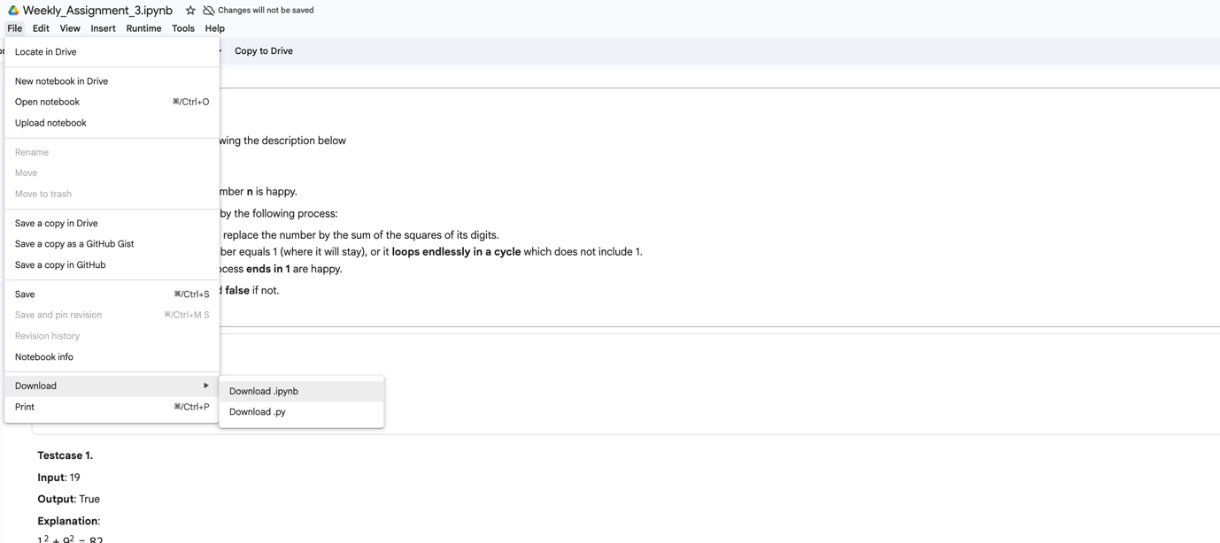
- Create a new repository named “SWE_2021_41_2026_2_week_4”
- Click “uploading an existing file” in the blue box
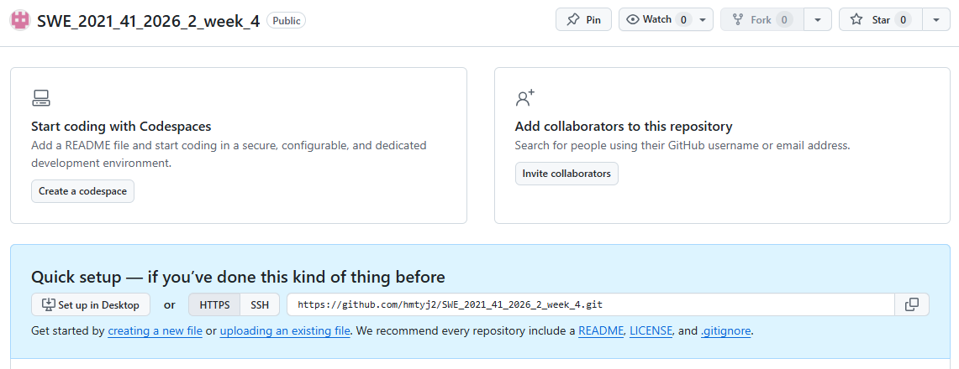
- Drag (Upload) the file and write a commit message. Finally, click “Commit changes”
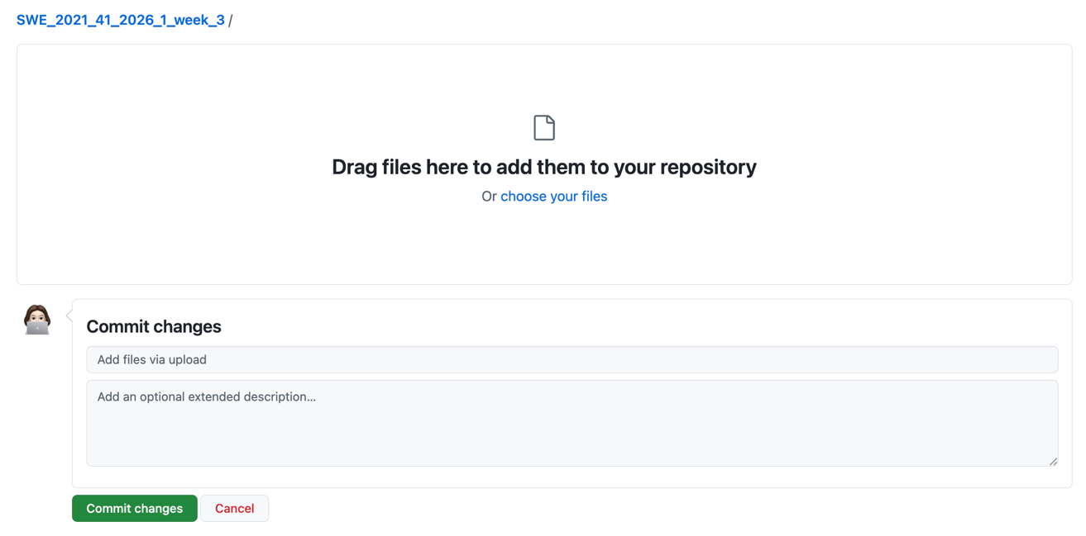

Evaluation
1. TA will grade the code by creating a copy of the student’s repository at
https://github.com/{YOUR_USERNAME}/SWE_2021_41_2026_2_week_4
2. TA will check the time when you committed and pushed lastly. The assignment pushed after due date(26/09/23 23:59) will not be graded.
3. If TA cannot access the repository at that address, the assignment will not be graded.
4. Students should submit GitHub ID to icampus (Only write your GitHub ID)
ex) dobbytk

Due date
26/09/23 23:59

